EDU Academy
SIKKIM MANIPAL UNIVERSITY

SYNOPSIS
ON
Library Management System

Submitted By
SATYAJIT NATH
Regd. No.: 520928214
Course: B.Sc(IT) 6th Sem

- Title
Library Management System – LMS.

- Introduction
Library management system is aimed to provide a system for the Librarian staff that can handle their daily transactions and mange the activities of library in an efficient and reliable way. It is to bring down the work load of library staff with the increased efficiency and to speed up the activities.
It keep all records of library i.e. storing details, details of availability of books, books issue details, borrowers details etc.

- Problem Definition
Manual record keeping is not a reliable method as people tend to forget things. For manually record keeping system a group of people have to involved in the process of managing the library and it may cost a lot & it will not be efficient for a library.
On the borrower’s point of view, in manual system borrower can’t find a book exactly at once as they are not ordered well. Sometimes user might be searching for a book that is not available in the library in such situation people get annoyed or depressed.

- Objectives
The Specific objectives of the LMS:
- Develop a system that can replace the manual library managing system.
- Develop a database which stores user details and book details.
- Give reliable search facility for the users.
- Administrator, librarian and users should have separate logins.

- Scope
The aim of this project is to develop a system that can handle & manage the activities involved in a library in an efficient & reliable way. The goal of the system is to bring down the work load with the increased efficiency and to speed up the activities. With this it is very easy to process course fee that is collected time to time from students who are registered and studying at franchisees.

- Methodology
  - Study of Existing System
- If one is not very careful then there is a possibility of issuing more than one book to a user.
- There is a possibility of issuing a book to a user, whose membership is not there.
- When a user requests for a book, one has to physically check for the presence of a book in the library.
- Answering management query is a time consuming process.
- Daily keeping a manual record of changes taking place in the library such as book being issued, book being returned etc can become cumbersome

  - Proposed system

The LIBRARY MANAGEMENT SYSTEM is a software application which avoids more manual hours in taking the book, that need to spend in record keeping and generating reports. Maintaining of user details is complex in manual system in terms of agreements, royalty and activities. This all have to be maintained in ledgers or books. Co-coordinators needs to verify each record for small information also.

- Easy search of book in the online library.
- Avoid the manual work.
- User need not go to the library for Issue any kind of book, he can renewal the book online.

  - Feasibility Study
Feasibility analysis is conducted once the problem is clearly understood. Feasibility analysis is a high level capsule version of the entire system analysis and design process. The objective is to determine quickly at a minimum expense how to solve a problem. The purpose of feasibility is not to solve the problem but to determine if the problem is worth solving.

The system has been tested for feasibility in the following points.
1. Technical Feasibility
2. Operational Feasibility.
3. Economical Feasibility

- System Planning

GANTT CHART:
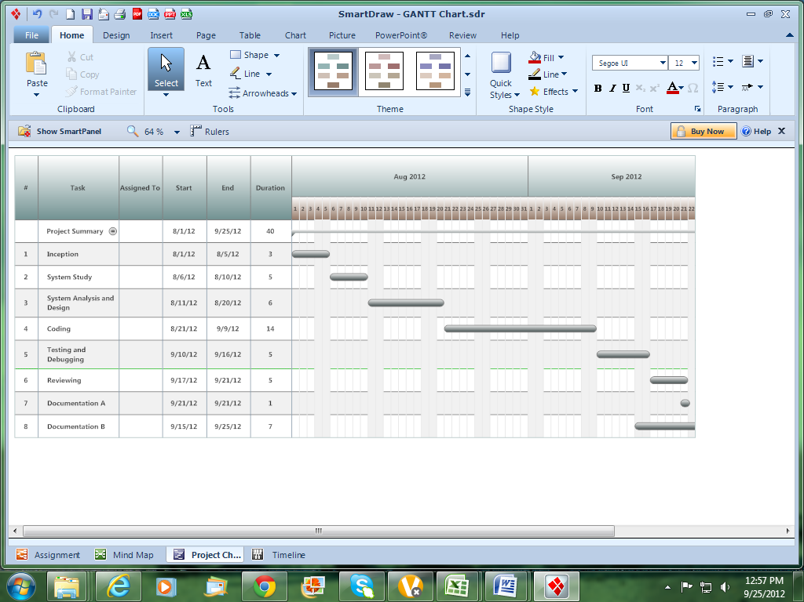

- System Overview
Context Diagram:

LMS
Librarian
Students
Login
Update information
Search Books Details

Administrator
Search Issue Details

- System Environments
Hardware:
- Pentium 4 or above
- RAM 512 MB or above
- Hard Disk-20 GB or above
Software:
- Windows Operating System
- MS Visual Studio 2005/ 2008
- ASP.NET
- C#
- SQL Server Management Studio 2008 R2
- Web Browser
- Testing Method
During the development or coding phase of the system, testing will be continued and system will be made error free as far as possible.
For testing purpose, Unit Testing will be used.
Unit testing refers to tests that verify the functionality of a specific section of code, usually at the function level. So each component/functionality will be tested and compared with desired output.
- Modules
Following modules will be available in the system.
Login Component
• Administrator (Head office manager)
• Librarian
• User
Administrator Component
• Administrator
Librarian Manager Component
• Librarian Manager
Student Component
• Books Details
• Issue Details
- System Development
Front-end:
Microsoft Visual Studio will be used as front-end development too. C# is used as programming language for the system.
Back-end:
SQL Server 2008 will be used as database backend for LMS.

- Conclusion
So, this library management system will develop a system that can replace the manual work. The work load of the administrator is reduced to a great extent by computerized transactions and instant information about the books in the library. It will also provide a common platform for Administrators, Librarians and Students to communicate globally.

